 **Westfield URC**

**Weekly Notice Sheet**

**For 14th February 2021**

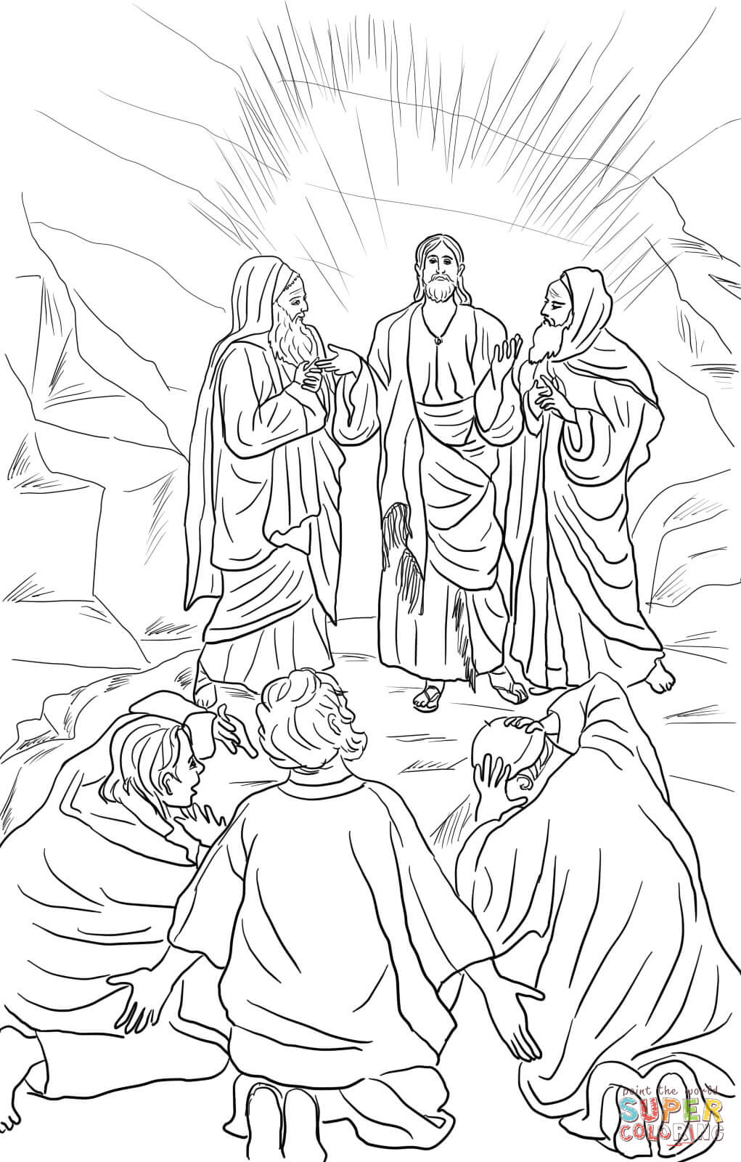

**If you have anything you want to share with the fellowship week by week please email it to Kath by Tuesday evening or ring and we will try to include it on the next weekly sheet.**

**Secretary: Kath Lonsdale: 01274 315203; 07759525936**

[**kathlonsdale@talktalk.net**](mailto:kathlonsdale@talktalk.net)

**Treasurer: Marjorie Hunt: 01274 677115**

**Westfield elders invite you to use the readings, prayers and reflections at 10.30am Sunday morning to help us worship together in Spirit. This week Andrew shares with us.**

**If you need someone to pray with, a chat or need any help Please ring any elder.**

|  |  |  |  |  |
| --- | --- | --- | --- | --- |
|  |  |  |  |  |

**A big thankyou to Carol, Kath & Andrew for delivering weekly sheets since last March.**

Due to the current lockdown & URC advice our opening date has moved to Sunday 7th March.

We trust in God for His plan for our future and look forward to the time that we can physically worship together again.

**In your envelope there is a Live Lent booklet – the daily readings start on Ash Wednesday 17th February. An extra opportunity for us all to share together in spirit as we journey through Lent.**

**A very Happy 80th Birthday**

**Pauline (H)**

**from all your**

**Westfield friends**







**Basil’s memories (30)**

The excitement of the wedding day was still to come and we were out and about in Burnie, a town not quite as big as Brighouse, where we walked along a lovely sandy beach not really a seaside resort but very popular in Summer with locals. We walked over to The Gospel Hall with the balustraded Police Station opposite. Peter and his best man had been engaged in building a house on a hill just outside the town, they still had lots of work to do, but what struck me was a boundary hedge on one side that was bulging with brilliant yellow mimosa, approximately 100 yards long. The perfume filled the whole area.

Peter and Karene had a practice run on the Friday evening and the Hall was made ready for the ceremony – and so to the big day.

Two features were outstanding to me – the bridal suite arrived in two veteran cars decorated with ribbons and tin cans. One was a 1930’s Jowett 10 (yes – made in Bradford), know as ‘Tabitha’ because, having been thoroughly refurbished she was ‘Full of good works’ – look up Acts ch.9 v 36 (AV) ! Of course the bride looked gorgeous. The other feature was Karene had 42 brothers and sisters in support. Her parents had worked as foster parents for nearly thirty years, sometimes for as many as six at a time. Of course some were only there for a few weeks. One was almost adopted, had been there nearly 30 years. After the reception some of us went to see them off for their honeymoon on Fiji, and to collect Peter’s car from Launceston airport.

It had been a full day and it was nice to be ‘home’ in Smith Street again. The following day was The Lord’s Day and we were back at the Gospel Hall again. It was then I noticed the lemon tree in the back garden. It seemed as if everybody in Smith Street had a lemon tree. Easy to grow and yielding two crops most years.

Tasmania is shaped like a triangle and so far we haven’t gone far from the northern coastline and it’s nearly 250 miles to the southern tip, so we have some ground to cover. Next time we go south. You’ll be amazed?

*BPH*

Westfield's%20Prayer%20for%20growth.pdf

Noticeboard witness:

For those not walking past church

this week’s poster is:

“Wherever you go I will go.

Your people will be my people

and your God my God”

Ruth 1 v 17

**Westfield URC, Westfield Lane, Wyke, BD12 9DB** [**www.westfieldurc.org**](http://www.westfieldurc.org)**.uk**

**please look at the calendar for future information or ring any elder Marjorie, Pauline, Neil, Glynis or Kath.**